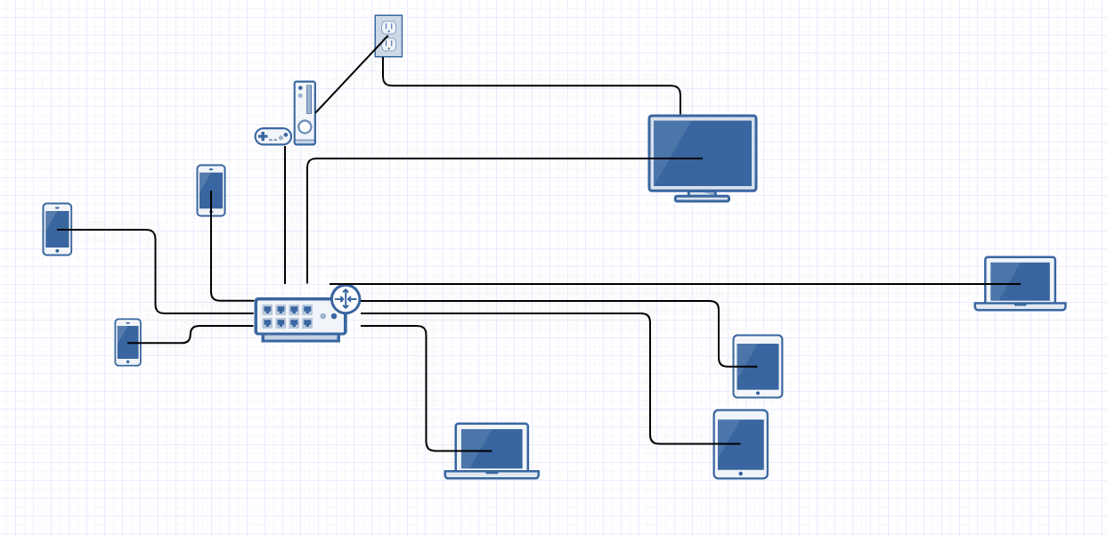

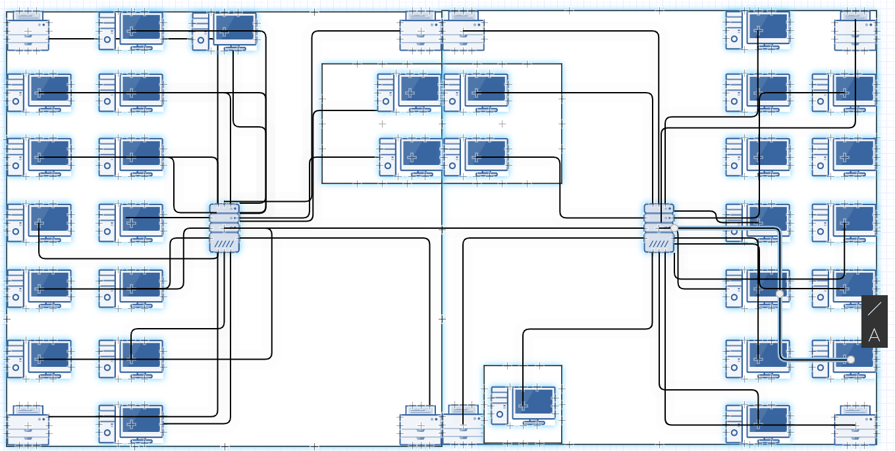

The router is a Data Communication Equipment. The TV, tablets, game console, phones and laptops are Data Terminal Equipment.

A disadvantage of my home network setup is that it will be slow because a lot are connected wirelessly. An advantage is that devices can all be updated at once because they are all connected.